BATCH VS REAL TIME PROCESSING
Agenda:
- Batch processing
- Real time processing
- Choosing the right approach
- Stream Processing
- Lambda architecture
  - Components
  - Working
  - Benefits
  - Challenges
Batch Processing
Batch processing is a data processing method where data is collected, grouped into batches, and processed together as a single unit. Unlike real-time processing, which processes data as it is generated, batch processing involves aggregating data over time and performing processing tasks at predetermined intervals or when specific conditions are met. This makes batch processing ideal for scenarios where immediate processing is not required, but large volumes of data need to be analyzed efficiently.
Characteristics of Batch Processing
- Delayed Processing:
  - Data is processed only after it has been collected into batches.
  - Results are not immediate, but processing is often more comprehensive and resource-efficient.
- High Throughput:
  - Processes large volumes of data in a single go, optimizing computational resources.
- Economical:
  - Since resources are allocated for processing at intervals, it often reduces costs compared to constant real-time processing.
- Sequential Operation:
  - Batches are processed in sequence, ensuring tasks are completed systematically.
How Batch Processing Works
- Data Collection:
  - Data is collected continuously from various sources, such as databases, APIs, or logs.
  - The data is stored until a predefined trigger is met, such as reaching a specific volume or a scheduled time.
- Batching:
  - Data is grouped into batches based on criteria like:
    - Time intervals: Hourly, daily, or weekly batches.
    - Transaction boundaries: Grouping similar transactions for efficient processing.
- Processing:
  - Each batch undergoes a set of predefined operations, such as:
    - Transformations: Cleaning, aggregating, or enriching the data.
    - Calculations: Running complex computations or analyses.
    - Integrations: Combining data from multiple sources.
- Result Generation:
  - Processed data is stored in a target system, such as:
    - Data Warehouses: For analytical purposes.
    - File Systems: For archival and backups.
    - Dashboards or Reports: For business insights.
Advantages of Batch Processing
- Resource Efficiency:
  - Processes large datasets in bulk, optimizing resource usage.
  - Computing resources are only active during scheduled processing periods.
- Consistency:
  - Ensures data quality and integrity by processing data in a controlled manner.
- Cost-Effective:
  - Reduced need for constant system operation compared to real-time processing.
- Scalability:
  - Suitable for growing datasets, as the batch size can be adjusted.
- Use of Historical Data:
  - Analyzes trends over time, providing valuable insights from large datasets.
Challenges in Batch Processing
- Complex Maintenance:
  - Requires ongoing management to ensure pipelines are stable and reliable.
  - Small errors, such as incorrect date formats or missing records, can disrupt entire workflows.
- Latency:
  - Results are delayed, making it unsuitable for time-sensitive tasks.
- Handling Missing Data:
  - Missing records or corrupted batches can block downstream processes, requiring robust error-handling mechanisms.
- Resource-Intensiveness:
  - Large batches require significant hardware and software resources.
Use Cases for Batch Processing
- Healthcare:
  - Analyze large volumes of patient data to identify trends and correlations.
  - Example:
    - The Mayo Clinic processes datasets of genetic information and treatment histories to identify predictive markers for diseases.
- Retail:
  - Optimize inventory and track sales trends by analyzing transactional data.
  - Example:
    - Walmart uses batch processing to analyze daily sales data for inventory optimization.
- Publishing:
  - Analyze sales data over specific periods to track bestselling titles and market dynamics.
  - Example:
    - Penguin Random House processes monthly sales data from bookstore chains to determine marketing strategies.
- Financial Services:
  - Process transactional data to generate periodic financial reports or fraud detection.
- Log Processing:
  - Analyze server logs in batches for system performance monitoring or cybersecurity insights.
Micro-batch processing
Micro-batch processing is a data processing technique where incoming data is grouped into small, time-bound batches for processing. These batches are created at very short intervals (e.g., seconds or milliseconds), allowing the system to process and deliver results close to real time.
How Micro-Batch Processing Works
- Data Collection:
  - Data is continuously ingested from sources like sensors, logs, or user actions.
  - Instead of processing each individual data point as it arrives (like in pure stream processing), data points are buffered temporarily.
- Batch Creation:
  - The buffered data is grouped into micro-batches based on a fixed time window or a predefined data volume. For example:
    - A batch every 5 seconds.
    - A batch containing 1,000 records.
- Processing:
  - Each micro-batch is processed independently using batch processing techniques, such as aggregations, transformations, or enrichments.
  - Tools like Apache Spark Streaming and Apache Flink (in bounded mode) execute the operations on these batches.
- Output:
  - Processed data is emitted as results for further use (e.g., updating a real-time dashboard or triggering an alert).
Micro-Batch Processing as a Subset of Batch Processing
Micro-batch processing is fundamentally batch processing applied to smaller, time-bound data segments. To understand why, let’s explore the characteristics they share:
- Batching of Data:
  - Both divide data into discrete units called "batches."
  - In micro-batch processing, the batches are significantly smaller in size or time span.
- Sequential Processing:
  - Both process one batch at a time, completing one before moving to the next.
- Same Underlying Techniques:
  - The transformations, aggregations, and processing methods used in traditional batch processing are also applied to micro-batches.
- Fault Tolerance:
  - Both techniques rely on mechanisms like checkpointing or recovery from logs to handle failures.
The key distinction is the frequency and size of the batches. In traditional batch processing, batches are large and processed less frequently, whereas micro-batches are smaller and processed continuously or in near real time.
Differences Between Micro-Batch and Batch Processing
Aspect | Batch Processing | Micro-Batch Processing
Batch Size | Large (e.g., millions of records) | Small (e.g., hundreds or thousands)
Time Window | Long (hours, days, or weeks) | Short (seconds or milliseconds)
Latency | High (results available after a delay) | Low (near-real-time results)
Processing Speed | Slower due to larger data volumes | Faster due to smaller batches
Use Case | Periodic reporting, historical analysis | Real-time dashboards, alerting systems
Infrastructure | Optimized for large-scale computation | Requires low-latency streaming systems
Example Tools | Hadoop, traditional ETL frameworks | Spark Streaming, Flink (bounded mode)
- Advantages:
  - Balances simplicity (batch model) with near-real-time requirements.
  - Easier to implement compared to pure stream processing.
  - Fault-tolerant due to batch-like processing mechanisms.
- Disadvantages:
  - Cannot achieve the true real-time latency of stream processing.
  - Increased resource usage due to frequent batch creation and processing.
- Typical Use Cases:
  - Real-time monitoring (e.g., server health or IoT sensors).
  - Updating leaderboards or metrics dashboards.
  - Triggering alerts when thresholds are exceeded.
When to Use Micro-Batch Processing
- When strict real-time latency (e.g., milliseconds) is not critical, results must be available quickly (e.g., within seconds).
- When you prefer to use batch-style processing techniques for easier debugging, scaling, and fault recovery.
Real-Time Processing
Real-time processing refers to the immediate collection, processing, and analysis of data as it becomes available. Unlike batch processing, which aggregates data over time for processing in bulk, real-time systems process individual data points or small groups of data as soon as they arrive. This enables organizations to make swift decisions and take immediate action based on current information.
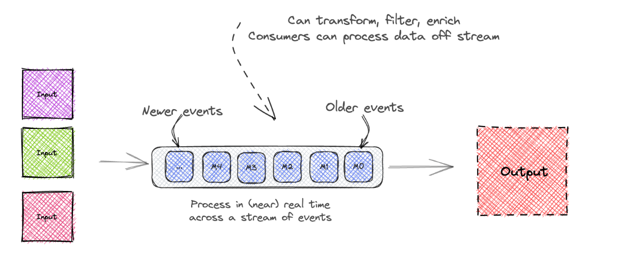
Characteristics of Real-Time Processing
- Low Latency:
  - Data is processed with minimal delay from the time it is generated to the time insights are derived.
- Continuous Data Flow:
  - Operates on a steady stream of data, ensuring continuous processing.
- Incremental Updates:
  - Insights are updated incrementally as new data becomes available.
- Immediate Decision Making:
  - Enables real-time actions, such as fraud prevention or personalized recommendations.
- Scalability:
  - Systems are designed to handle high-throughput data streams from multiple sources simultaneously.
How Real-Time Processing Works
- Data Ingestion:
  - Data is continuously ingested from multiple sources such as:
    - IoT Sensors: Devices like temperature sensors, GPS trackers, or industrial monitors.
    - Applications: User activity logs, clickstreams, or transactions.
    - Databases: Both structured (SQL) and unstructured (NoSQL).
    - Streaming Platforms: Apache Kafka, Apache Pulsar, or AWS Kinesis.
- Example: A stock market monitoring system ingests price updates for thousands of stocks every millisecond.
- Processing and Analysis:
  - Data is processed immediately upon ingestion. This includes:
    - Mathematical Calculations: Summing, averaging, or statistical modeling.
    - Pattern Recognition: Detecting anomalies, trends, or specific sequences.
    - Predictive Modeling: Using machine learning algorithms to forecast future outcomes.
- Example: In fraud detection, each transaction is analyzed in real time to identify suspicious patterns.
- Actionable Insights:
  - Results from the analysis are presented through:
    - Dashboards: Real-time visualizations of key performance indicators (KPIs).
    - Alerts: Notifications for anomalies or critical events.
    - Automated Responses: Triggering actions like blocking a fraudulent transaction.
- Example: In a smart grid system, real-time dashboards show power usage patterns, and alerts are sent if consumption exceeds thresholds.
Advantages of Real-Time Processing
- Faster Decision-Making:
  - Provides instant insights that enable businesses to respond proactively.
- Improved Customer Experience:
  - Personalizes user interactions in real time, enhancing satisfaction and engagement.
- Operational Efficiency:
  - Identifies inefficiencies or anomalies immediately, reducing downtime or waste.
- Enhanced Security:
  - Detects and prevents fraud or cyberattacks as they occur.
- Competitive Edge:
  - Real-time capabilities allow businesses to act faster than competitors.
Challenges in Real-Time Processing
- Data Latency and Volume:
  - High data volumes can create latency issues if systems are not optimized.
  - Requires scalable architectures to maintain performance.
- Data Quality and Accuracy:
  - Errors, duplicates, or inconsistencies in incoming data streams can compromise results.
  - Real-time validation and cleansing mechanisms are necessary.
- Complexity of Implementation:
  - Building and maintaining real-time systems demands expertise in distributed systems, networking, and scalability.
- Cost:
  - Continuous operation and the need for high-performance infrastructure can lead to significant costs.
Use Cases for Real-Time Processing
1. Banking and Finance:
- Fraud Detection:
  - Real-time systems analyze credit card transactions for anomalies and flag potentially fraudulent activities.
- Example:
  - JPMorgan Chase uses real-time fraud detection systems to analyze transaction attributes (location, amount, merchant) and compare them against historical patterns. Transactions flagged as suspicious are blocked, and customers are alerted.
2. Streaming Media:
- Personalized Recommendations:
  - Streaming platforms deliver content suggestions based on user activity in real time.
- Example:
  - Netflix updates user dashboards with tailored recommendations immediately after a user finishes watching a show, using collaborative filtering and content-based algorithms.
3. Retail and E-Commerce:
- Customer Service:
  - Chatbots resolve customer queries instantly.
- Example:
  - Amazon utilizes real-time NLP algorithms in its chatbot to provide order updates or answer product-related questions while learning from each interaction to improve responses.
4. Healthcare:
- Patient Monitoring:
  - Real-time systems track vital signs in ICU patients and alert medical staff of abnormalities.
- Example:
  - A hospital system monitors heart rate, oxygen levels, and blood pressure, triggering alarms for immediate intervention if thresholds are exceeded.
5. Transportation:
- Fleet Tracking:
  - Logistics companies monitor vehicle locations and optimize delivery routes dynamically.
- Example:
  - Uber processes millions of GPS updates per second to match drivers with riders and calculate real-time ETAs.
6. Cybersecurity:
- Threat Detection:
  - Real-time systems monitor network traffic for signs of attacks or breaches.
- Example:
  - Intrusion detection systems flag unusual patterns like repeated login failures or abnormal file access.
Popular Tools for Real-Time Processing
- Apache Kafka:
  - Distributed streaming platform used for building real-time data pipelines and event-driven architectures.
- Apache Flink:
  - Framework for real-time stream processing with low latency and high throughput.
- AWS Kinesis:
  - Managed service for collecting, processing, and analyzing real-time data streams.
- Google Cloud Dataflow:
  - Fully managed service for real-time data processing using Apache Beam SDK.
Choosing the Right Approach:
Real-Time vs. Batch Data Processing
The decision between real-time and batch data processing is crucial for optimizing data workflows, achieving business objectives, and balancing cost and performance. Each approach is tailored to specific data characteristics, operational needs, and use cases. Here’s a detailed analysis of how to choose the right data processing approach.
Criteria for Decision-Making
1. Data Volume
- Real-Time Data Processing:
  - Best suited for large data streams requiring immediate analysis.
  - Handles high-throughput environments where data is continuously generated, such as:
    - Sensor Data: IoT devices emitting readings every second.
    - Web Logs: Continuous user activity on websites or apps.
    - Clickstream Data: Tracking user clicks and navigation paths in real-time.
- Batch Data Processing:
  - Suitable for low-volume datasets that can be processed at scheduled intervals.
  - Ideal for environments where data accumulates over time before analysis, such as:
    - Sales Data: Summarized daily or weekly for performance reports.
    - Inventory Data: Periodic updates to track stock levels.
    - Customer Feedback: Surveys collected over a month for aggregated insights.
2. Data Speed
- Real-Time Data Processing:
  - Excels with high-speed data that has rapid changes and short shelf life.
  - Critical for scenarios where immediate insights are necessary, such as:
    - Stock Prices: Reacting to market changes within milliseconds.
    - Weather Data: Providing updates and alerts for dynamic conditions.
    - Social Media Trends: Capturing viral topics as they emerge.
- Batch Data Processing:
  - Works well with low-velocity data, where changes occur slowly and data retains value over a longer period.
  - Effective for historical or retrospective analysis, such as:
    - Financial Data: Aggregating quarterly earnings.
    - Demographic Data: Analyzing census data collected over years.
3. Data Diversity
- Real-Time Data Processing:
  - Handles diverse data types, including unstructured, semi-structured, and structured formats.
  - Suitable for heterogeneous data sources like:
    - Text: Social media comments or emails.
    - Images and Videos: Analyzing multimedia content from surveillance or user uploads.
    - Audio: Processing real-time voice commands or call center data.
- Batch Data Processing:
  - Designed for homogeneous, structured data, such as tabular or serialized formats.
  - Commonly used with:
    - CSV Files: Sales records or financial transactions.
    - JSON/XML: Data from APIs or system logs.
    - Database Tables: Structured records from relational databases.
4. Data Value
- Real-Time Data Processing:
  - Suitable for high-value data that directly impacts operations or requires immediate decisions.
  - Common use cases include:
    - Fraud Detection: Identifying suspicious transactions in real-time to prevent losses.
    - Anomaly Detection: Monitoring critical systems for deviations (e.g., server downtime).
    - Personalized Recommendations: Providing instant suggestions based on user actions.
- Batch Data Processing:
  - Ideal for low-value data that contributes indirectly to operations, such as planning and strategy.
  - Examples include:
    - Reports: Quarterly performance reviews.
    - Dashboards: Summarized metrics for management decisions.
    - Trend Analyses: Studying long-term customer behavior.
Practical Considerations
- Operational Context:
  - Real-time systems are essential in fast-paced environments like e-commerce, financial markets, and healthcare, where time-sensitive decisions are critical.
  - Batch systems are better suited for industries like publishing, retail, or academic research, where periodic data aggregation suffices.
- Infrastructure and Cost:
  - Real-time systems require high-performance, scalable infrastructures, often leading to higher costs in terms of hardware, software, and skilled personnel.
  - Batch systems are more resource-efficient and cost-effective for applications that do not demand instant processing.
- Scalability:
  - Real-time systems must scale horizontally to handle increased data streams without compromising latency.
  - Batch systems can scale based on processing schedules, offering flexibility for large datasets processed in intervals.
- Integration with Business Goals:
  - If your business needs to respond to events as they occur (e.g., customer interactions, system failures), real-time processing is indispensable.
  - If your goals revolve around long-term analysis and planning, batch processing is more aligned with your needs.
Use Case Examples
Industry | Real-Time Processing | Batch Processing
E-Commerce | Delivering personalized recommendations during user browsing. | Generating monthly sales reports for product trends.
Banking | Detecting fraudulent transactions in real-time. | Calculating end-of-day account balances.
Healthcare | Monitoring ICU patient vitals for anomalies. | Analyzing historical patient outcomes for research.
Transportation | Optimizing delivery routes dynamically. | Reviewing yearly fleet maintenance logs.
Media | Streaming content recommendations on-the-fly. | Aggregating viewership metrics for quarterly reviews.
Blended Approach: Real-Time and Batch Processing
In some cases, businesses may combine real-time and batch processing to leverage the strengths of both approaches. This hybrid model is particularly useful when organizations need both immediate insights and historical analysis. For example:
- Retail:
  - Use real-time processing to track inventory levels and trigger restocking alerts.
  - Use batch processing to analyze seasonal trends for inventory planning.
- Healthcare:
  - Monitor patients in real-time for critical conditions.
  - Use batch processing to analyze patient demographics and long-term treatment effectiveness.
Stream Processing
Stream processing is a computing paradigm designed to process and analyze continuous flows of data (streams) in real-time or near real-time. Unlike traditional batch processing, which processes data in large, static chunks after all the data has been collected, stream processing operates on data as it arrives.
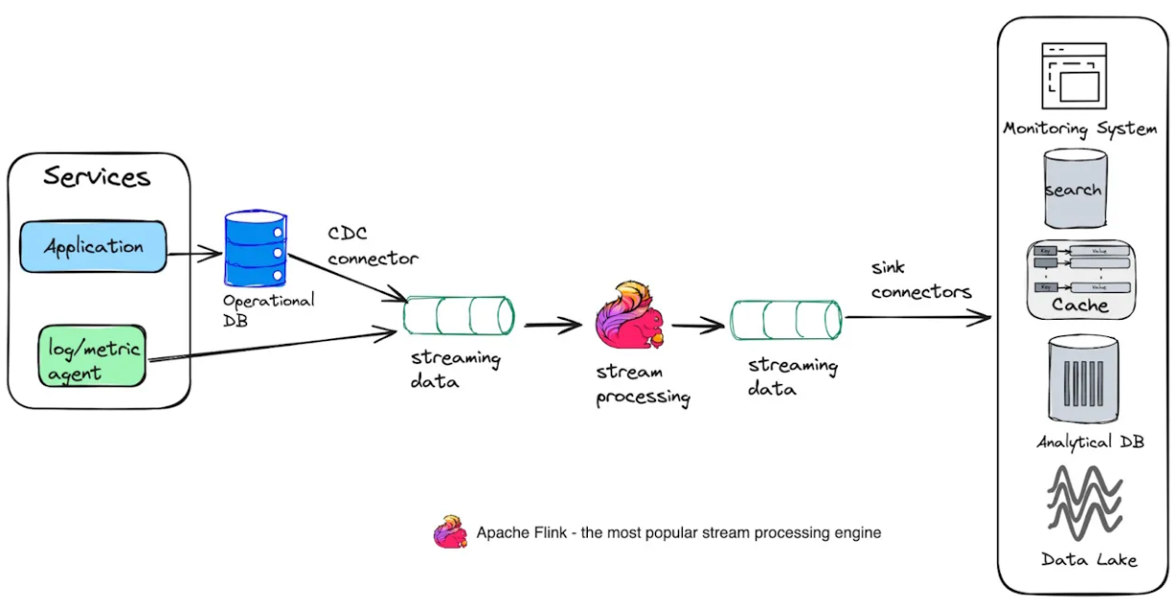
Characteristics of Stream Processing
- Continuous Data Flow:
  - Data is processed incrementally as it arrives in real-time.
  - Examples: IoT sensor readings, user activity logs, social media feeds, stock market data.
- Low Latency:
  - Provides insights within milliseconds to seconds after data generation.
  - Suitable for use cases where immediate action is required, such as fraud detection or system monitoring.
- Event-Driven:
  - Each incoming data point or event is processed as part of the stream.
  - Events can trigger actions or be used to update aggregate metrics.
- Scalability:
  - Can handle large volumes of data efficiently.
  - Supports distributed processing across multiple nodes.
- Temporal Nature:
  - Operations are often time-sensitive, with a focus on windows of time (e.g., sliding, tumbling, or session windows).
Why Is Stream Processing Important?
Stream processing enables organizations to derive insights and take action on data while it is still relevant. Traditional batch processing systems often introduce delays, which are unacceptable in time-critical scenarios. Below are the primary reasons why stream processing is needed:
- Time-Sensitive Insights:
  - Some data insights lose value quickly after an event occurs. For example:
    - Alerting when a temperature sensor detects freezing conditions.
    - Detecting fraudulent transactions before they are completed.
- Natural Fit for Continuous Data:
  - Many data sources generate continuous streams of data, such as IoT devices, web clickstreams, or financial transactions.
  - Stream processing handles such unbounded datasets gracefully without requiring manual partitioning into batches.
- Efficient Resource Utilization:
  - Spreads computation over time, avoiding the resource spikes associated with batch processing.
  - Enables approximate results through techniques like load shedding.
- Scalability for Big Data:
  - Processes vast amounts of data in real-time without needing to store all of it permanently.
  - Useful in scenarios where data volume is too high to store and process in batches.
How Stream Processing Works
- Ingestion:
  - Data flows continuously from sources such as sensors, message brokers (Kafka, RabbitMQ), or databases.
- Processing:
  - Data is processed in real-time using stream processing frameworks.
  - Common operations include filtering, transformations, aggregations, and joins.
- Windowing:
  - To handle infinite streams, data is grouped into finite chunks using time windows:
    - Tumbling Window: Non-overlapping fixed time intervals.
    - Sliding Window: Overlapping intervals with a sliding duration.
    - Session Window: Defined by periods of activity separated by inactivity.
- Output:
  - Processed results are sent to downstream systems such as databases, dashboards, or alerting systems.
Stream Processing Frameworks
Modern stream processing relies on specialized frameworks that handle the complexities of scalability, fault tolerance, and real-time computations. Key frameworks include:
- Apache Kafka Streams:
  - Provides stream processing capabilities on top of Kafka.
  - Decentralized and lightweight.
- Apache Flink:
  - Designed for both stream and batch processing.
  - Supports complex event processing and time-windowed computations.
- Apache Spark Streaming:
  - Uses micro-batching for near-real-time processing.
  - Built on Apache Spark.
- Apache Storm:
  - One of the earliest stream processing frameworks.
  - Processes data as discrete tuples in a distributed topology.
- Samza:
  - Developed by LinkedIn, tightly integrates with Kafka.
- WSO2 Stream Processor:
  - Offers high-throughput streaming with built-in support for SQL-like queries.
Stream Processing vs. Batch Processing
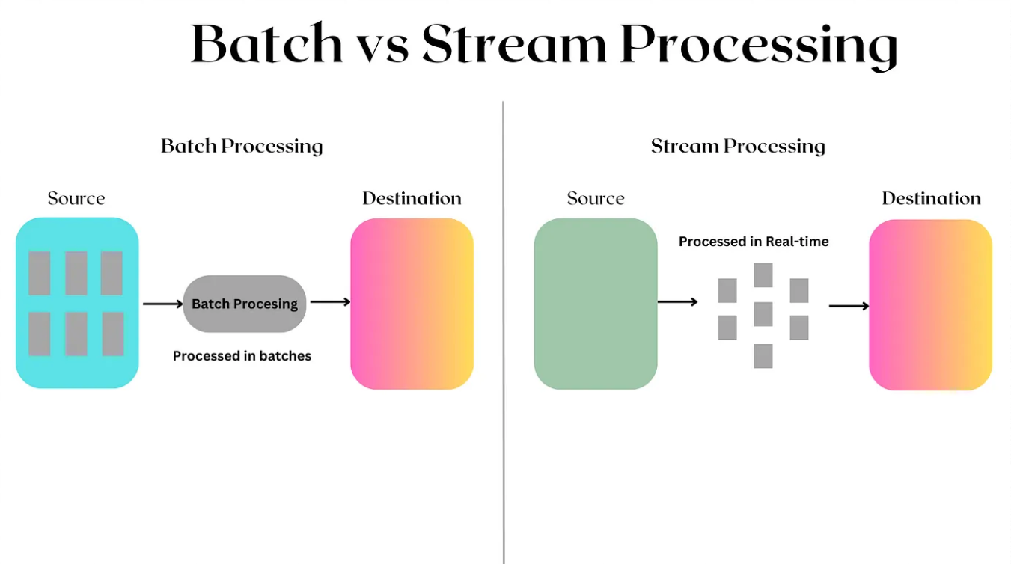
Aspect | Stream Processing | Batch Processing
Data Handling | Continuous, unbounded streams | Static, bounded datasets
Latency | Low (milliseconds to seconds) | High (hours to days)
Use Case | Real-time analytics, monitoring, and alerting | Historical analysis, periodic reporting
Resource Utilization | Spread over time | Resource-intensive during batch runs
Example Tools | Apache Flink, Kafka Streams, Apache Storm | Apache Hadoop, Spark Batch
Common Use Cases
- Real-Time Monitoring:
  - Detect anomalies or changes in metrics, such as CPU usage or stock prices.
- Fraud Detection:
  - Identify fraudulent activities in financial transactions as they occur.
- IoT Applications:
  - Process sensor data for predictive maintenance or environmental monitoring.
- Event-Driven Systems:
  - Trigger actions based on user activity, such as sending notifications or updating dashboards.
- Geospatial Analytics:
  - Track vehicle locations, detect geofencing violations, or analyze traffic patterns.
- Advertising and Personalization:
  - Deliver context-aware ads based on user activity in real time.
How to Implement Stream Processing
- With a Framework:
  - Use a framework like Apache Flink, Kafka Streams, or Spark Streaming.
  - Configure data sources, processing logic, and output sinks.
  - Frameworks handle scalability, fault tolerance, and distributed computation.
- Custom Implementation:
  - Use a message broker (e.g., Kafka or RabbitMQ) for ingestion.
  - Write custom code to process events and output results.
  - Requires manual handling of reliability, scaling, and data flow management.
Lambda Architecture
The Lambda Architecture is a design pattern specifically crafted for building scalable, fault-tolerant, and low-latency data processing pipelines. It combines batch processing for comprehensive and reliable computation of historical data with real-time stream processing for immediate insights. This architectural pattern is particularly valuable in domains requiring processing of high-velocity, high-volume, and high-variety data—collectively known as big data.
Principles of the Lambda Architecture
- Immutable Data:
  - All data entering the system is treated as an immutable, append-only log.
  - The raw, unaltered data is the single source of truth.
  - Ensures reprocessability, fault tolerance, and consistency.
- Separation of Concerns:
  - The architecture splits data processing into two distinct layers:
    - Batch Layer for high-latency, comprehensive processing.
    - Speed Layer for low-latency, incremental processing.
  - This division simplifies the logic in each layer.
- Eventual Consistency:
  - Queries on the system eventually return consistent results, blending historical (batch) data and real-time (speed) data.
- Scalability and Fault Tolerance:
  - Built on distributed systems that can scale horizontally to handle increasing data volumes.
  - Fault tolerance is achieved by redundant data storage and parallel processing.
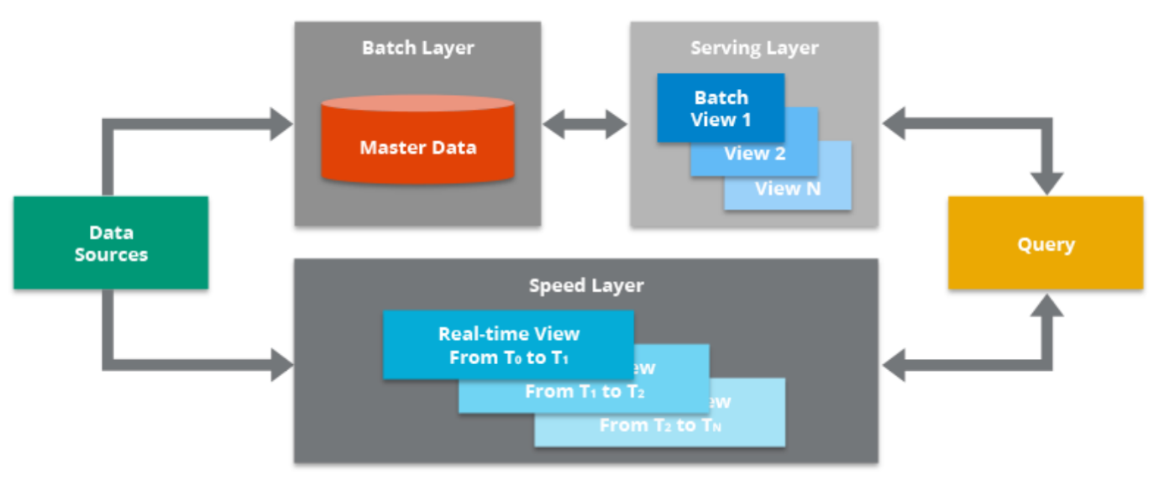
Architecture Components in Depth
1. Data Sources
- Origin of the raw data ingested into the Lambda Architecture.
- Types of Data:
  - Streaming Data: Continuous streams like user interactions, IoT sensor data, or financial transactions.
  - Batch Data: Periodic data dumps, such as end-of-day sales reports or monthly logs.
- Data Ingestion:
  - Parallel Ingestion: Data is routed simultaneously to the Batch Layer and the Speed Layer.
  - Technologies: Apache Kafka, Amazon Kinesis, or RabbitMQ.
2. Batch Layer
- Stores and processes the entire historical dataset in an immutable and comprehensive manner.
- Features:
  - Raw Data Storage: Maintains a permanent record of all incoming data.
  - Batch Views:
    - Results of batch processing.
    - Optimized and aggregated data for query execution.
- Processing Workflow:
  - Raw Data Storage:
    - Data is stored in cost-efficient, append-only storage (e.g., HDFS, Amazon S3).
    - Immutable data ensures data integrity and simplifies debugging.
  - Batch Processing:
    - Periodically processes the raw data into batch views.
    - Focused on accuracy and completeness rather than speed.
    - Example: Computing daily sales totals or monthly trends.
  - Output Storage:
    - Processed batch views are saved in the Serving Layer for querying.
- Technologies:
  - Storage: HDFS, S3, Google Cloud Storage.
  - Processing: Apache Hadoop (MapReduce), Apache Spark, Hive, or Presto.
3. Speed Layer
- Provides low-latency access to the most recent data by processing it in near real-time.
- Features:
  - Processes unindexed, newly arriving data.
  - Produces real-time views available for immediate querying.
  - Handles data only temporarily; older data is discarded once batch processing catches up.
- Processing Workflow:
  - Ingestion:
    - Receives streaming data directly from the source.
  - Real-Time Processing:
    - Applies lightweight transformations or aggregations.
    - Maintains minimal state for quick updates.
  - Output Storage:
    - Results are stored in memory or fast-access storage systems (e.g., Redis, Hazelcast).
- Technologies:
  - Apache Storm, Apache Flink, Apache Spark Streaming, or Kafka Streams.
4. Serving Layer
- Hosts the results from both the batch and speed layers for querying by end users.
- Features:
  - Consolidates data from the batch layer (batch views) and speed layer (real-time views).
  - Provides APIs or query interfaces for user interaction.
- Processing Workflow:
  - Indexing:
    - Batch views are indexed for efficient querying.
    - Queries are resolved by merging batch and real-time results.
  - Query Execution:
    - Executes user queries and provides unified, near-real-time responses.
- Technologies:
  - Databases: Cassandra, HBase, Elasticsearch, Druid.
  - Query Engines: Presto, Impala, or APIs.
5. Query Layer
- Interfaces with users or applications to fetch insights.
- Workflow:
  - Queries are sent to both the serving layer (batch views) and the speed layer (real-time views).
  - Results from both layers are merged to provide comprehensive, up-to-date responses.
- Technologies:
  - SQL-like tools, dashboards, or machine learning inference systems.
How the Lambda Architecture Works
- Data Arrival:
  - Data enters the pipeline from the source.
  - Sent simultaneously to the Batch Layer and the Speed Layer.
- Batch Processing:
  - Data is stored in an append-only, immutable format.
  - Processed periodically to generate batch views, which are saved in the serving layer.
- Real-Time Processing:
  - New data is processed immediately to create real-time views.
  - Temporary results cover the gap left by the batch layer’s latency.
- Query Execution:
  - User queries retrieve data from both batch and real-time views.
  - Results are merged to present a unified response.
- Handoff:
  - Once batch processing completes, the speed layer discards its copy of the now-indexed data.
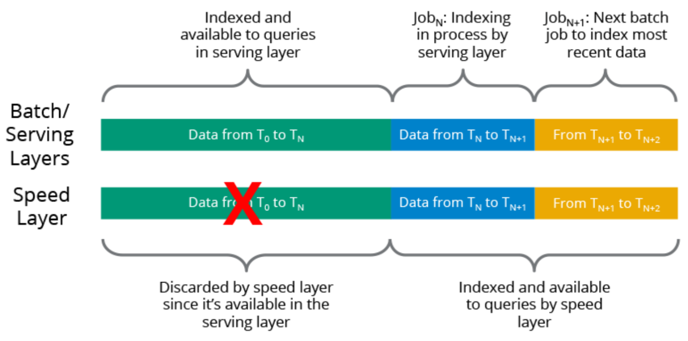
Benefits of Lambda Architecture
- Comprehensive Insights:
  - Combines historical and real-time data for a complete view.
- Low Latency:
  - Real-time insights ensure responsiveness.
- Fault Tolerance:
  - Redundant processing layers handle failures gracefully.
- Scalability:
  - Distributed systems support scaling with data volume.
- Debugging and Reprocessing:
  - Immutable data allows reprocessing in case of errors.
Challenges of Lambda Architecture
- Complexity:
  - Requires maintaining two separate pipelines (batch and speed).
- Consistency:
  - Ensuring synchronized logic and results between layers can be challenging.
- Cost:
  - Running two parallel pipelines can be resource-intensive.
- Latency in Batch Layer:
  - Batch processing inherently introduces delays.

